Pratyusha Thundena

Laboratory 3

FA2017 CS 103L-F4 Introduction to Computation Lab

September 29, 2017

Source Code

Figure 1:

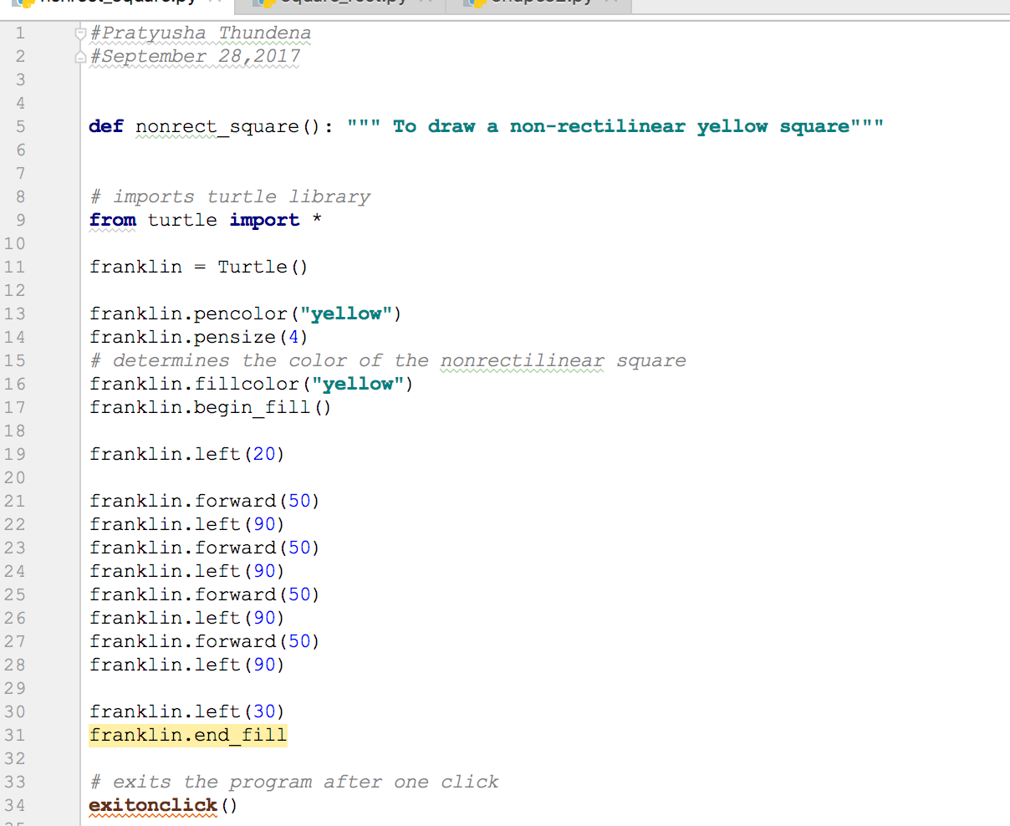

Figure 2:

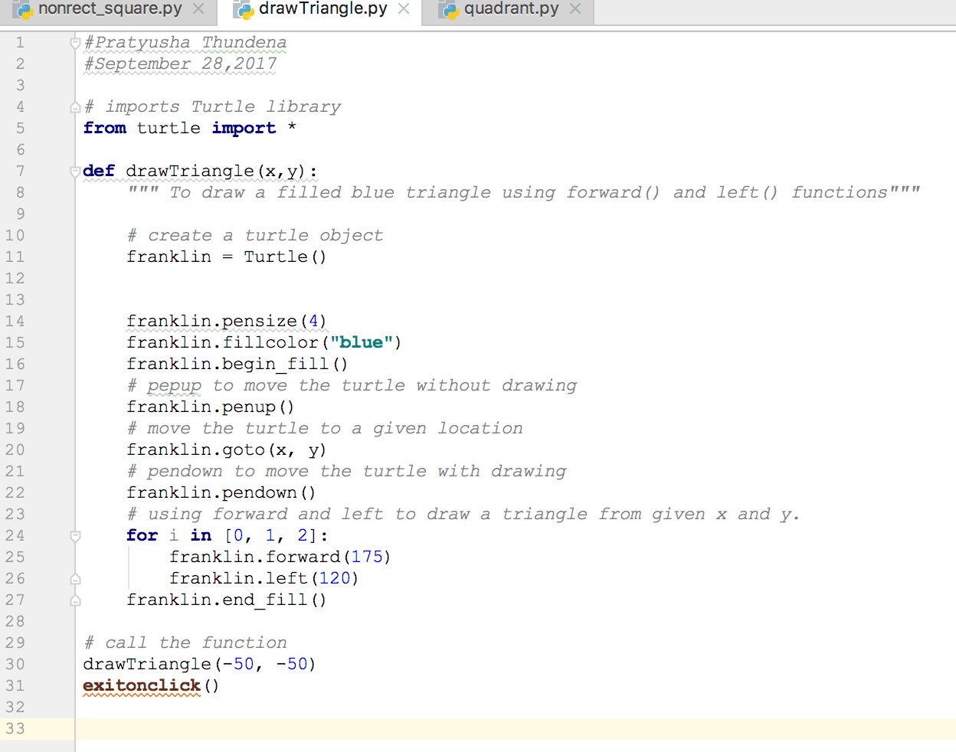

Figure 3:

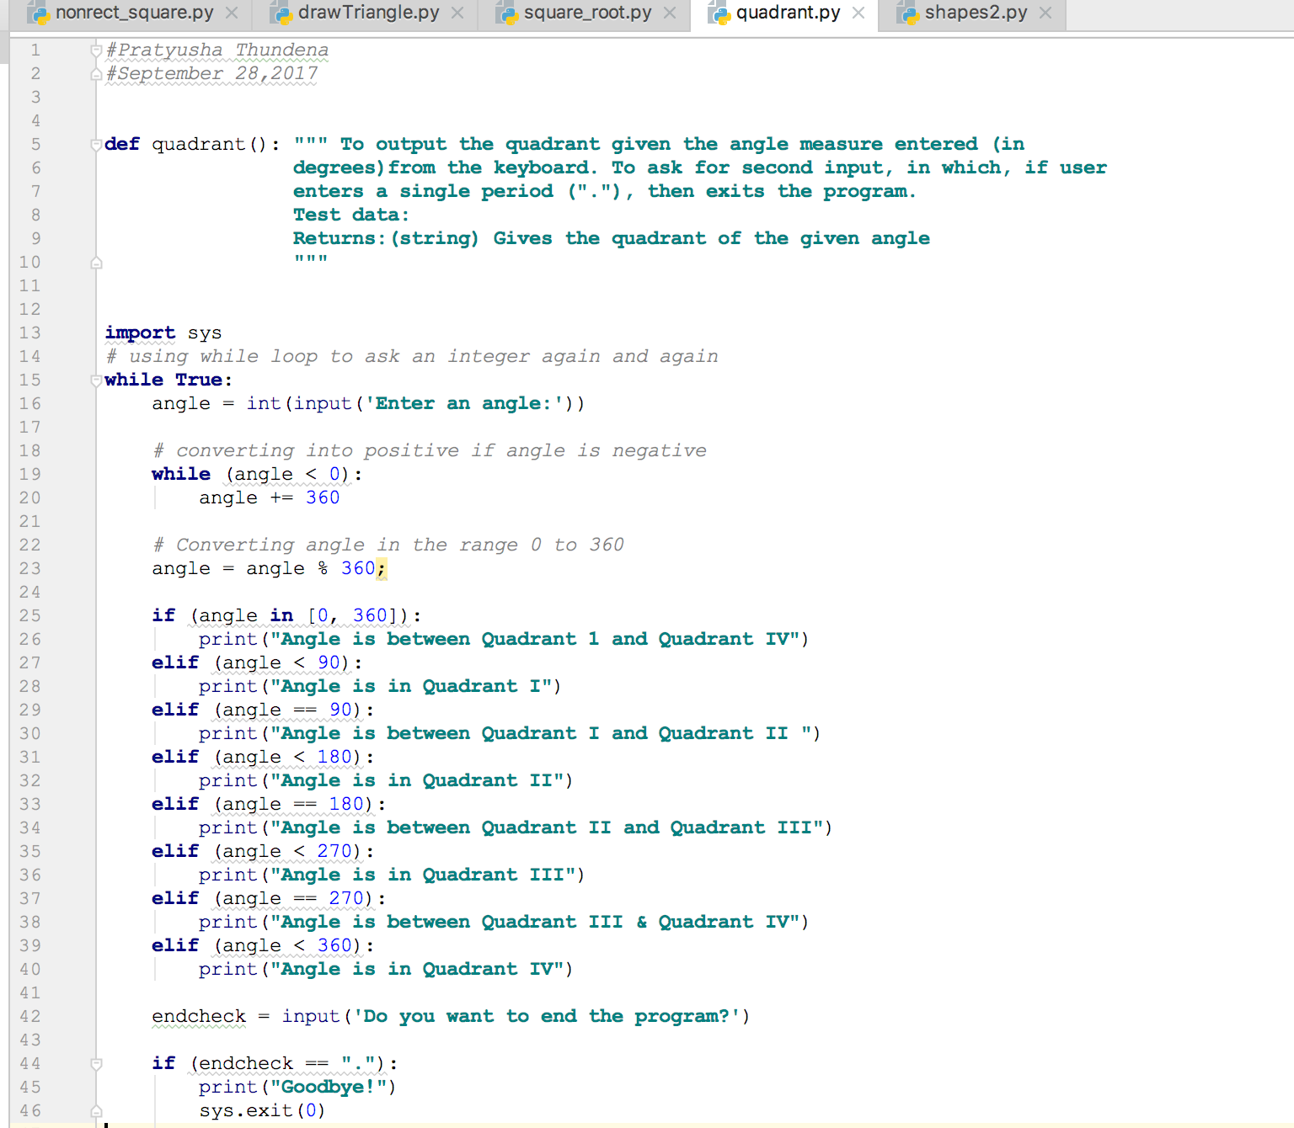

Demonstration to TA

Source codes demonstrated on 9/28/2017 at approximately 2:20 pm (CST) to BreAunna.

Program Results

Figure 1 Output:



Figure 2 Output:

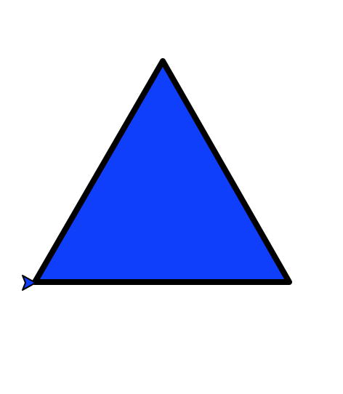

Figure 3A Output:

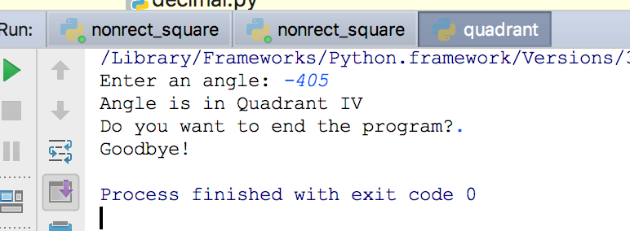

Figure 3B Output:

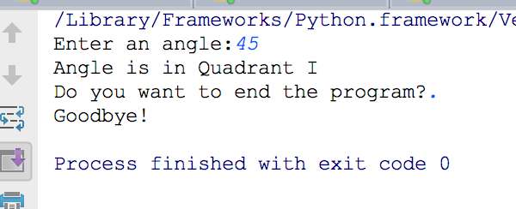

Figure 3C Output:

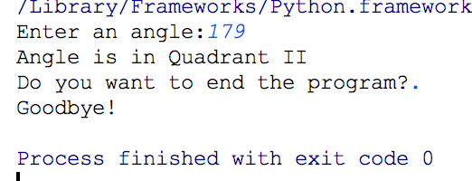

Figure 3D Output:

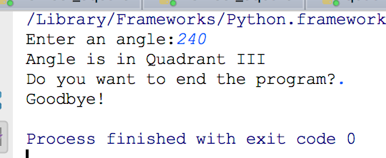

Conclusion and Results

This lab focused on improving our knowledge pertaining to Turtle graphics, which is a

drawing tool used to produce graphic designs on the screen. Before this lab, I did not know the

meaning of the term non-rectilinear square. After the lab, I learned that a non-rectilinear square

was a square that is not aligned vertically or horizontally (Figure 1 Output). The second part of

the lab involved using Turtle graphics in order to produce a filled blue triangle. This part of the

lab was quite different from previous labs since we had to write a function that took a starting

location (x, y) as arguments, and then the triangle had to be drawn with one apex at that location.

I realized that I could use x and y to get the program to start at a location that I specifically

desired (Figure 2 Output). The third part of the lab focused on creating a program that gave the

correct quadrant given an angle measure entered from the keyboard. The program had to ask the

user to input an angle number (in degrees) and then it should output to the screen which quadrant

the angle lies in. I realized I could do this portion of the program with if-else statements.

However, I ran into trouble when I had the user input a negative number as an angle. I was able

to solve this problem by using a while loop, which was demonstrated in Figure 3. I also had to

receive input from the user, such as, a string (“.”). When the user entered the previously

mentioned string, then that signaled the end of the program. As a result, the user got to exit the

program. This was the most challenging part of the program since I didn’t know how to exit the

program. I learned that I had to use the import sys function and sys. exit (0) function to exit the

program. Overall, the third lab taught me more functions and I had fun once I had the program

working. Figure 3A Output, Figure 3B Output, Figure 3C Output, and Figure 3D Output

illustrated that the user could enter an angle, and the program would correctly display the

given quadrant.